About the Ungraded Lab: Improve your Bio page with Bootstrap

In this Ungraded Lab, you will update your biographical page from Week 2 - Introduction to HTML5 and CSS to use Bootstrap.

The expected outcome is a two-column biographical page with your name and a photo in the left column and your favorite music artists and films in the right column.

The image below shows how your page should look once you finish the assessment.

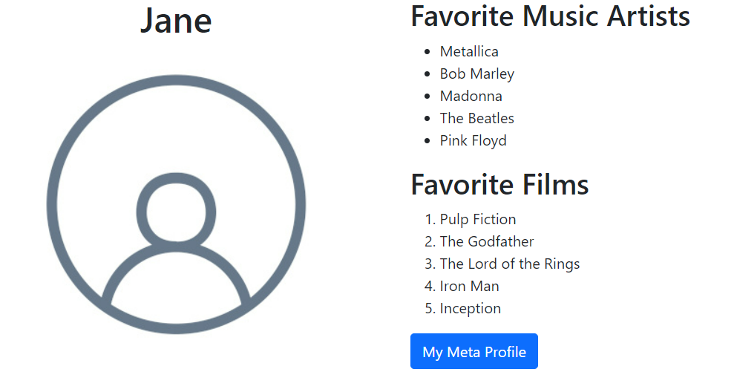

# Next steps after Introduction to Web Development

Congratulations! You've completed this course and taken another step toward improving your knowledge, skills and qualifications.

In the next course, you’ll learn about JavaScript. JavaScript is the programming language that powers the modern web. You will learn the basic concepts of web development with JavaScript. You will work with functions, objects, arrays, variables, data types, the HTML DOM and much more. You will learn how to use JavaScript within the React framework and discover interactive possibilities with modern JavaScript technologies. Finally, you will learn about the practice of testing code and how to write a unit test using Jest.